**SOFTWARE ENGINEERING LAB TASK 6**

**08-01-2025**

**HU22CSEN0100999**

**Eshwar Deshmukh Chavan**

**Aim:**

Create a weather prediction model using a quadratic equation, following the Waterfall model approach.

**Waterfall Model:**

The Waterfall model is a step-by-step software development process where each phase is completed before moving to the next.

**Phases:**

**Requirement Analysis**

* Collect weather data (e.g., temperature, humidity).
* Define the model's requirements and outputs.

**Design**

* Create the quadratic formula: y=ax2+bx+cy = ax^2 + bx + cy=ax2+bx+c.
* Plan the process using flowcharts and data structures.

**Implementation**

* Write the code for the quadratic model.
* Use Python for better flexibility and visualization.

**Verification**

* Test the model using past weather data.
* Check if predictions are accurate.

**Deployment**

* Deliver the system for use in real-world scenarios.
* Ensure it’s user-friendly and reliable.

**Maintenance**

* Update the model as needed for accuracy.
* Regularly review its performance.

**Steps Of Implementation:**

1. Import Libraries

Imports NumPy for calculations and Matplotlib for plotting.

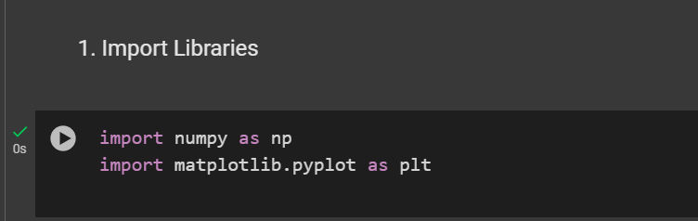

1. Define Quadratic Function

Defines a quadratic function y=ax2+bx+c to model the stages of the Waterfall Model.

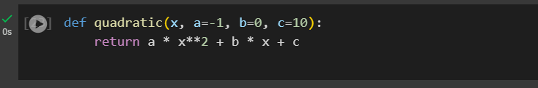

1. Waterfall Model Visualization with Quadratic Curve

Plots a quadratic curve representing the stages, with markers and vertical lines for the waterfall effect.

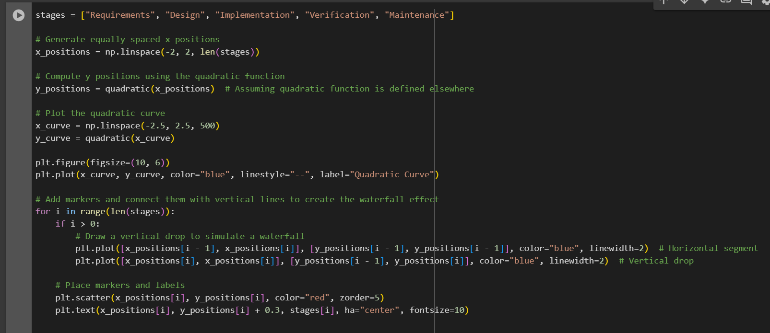

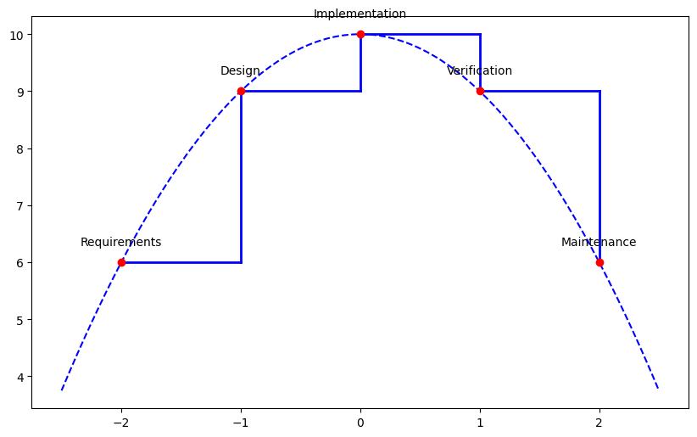

1. Style and Show the Plot

Adds titles, labels, grid, and a legend, then displays the plot.



